«GreetingLine»
“Warm greetings to you and your loved ones on the auspicious occasion of Diwali! May this festival of lights bring infinite happiness, wealth, and prosperity into your lives.”
“Wishing you a Happy Diwali!”

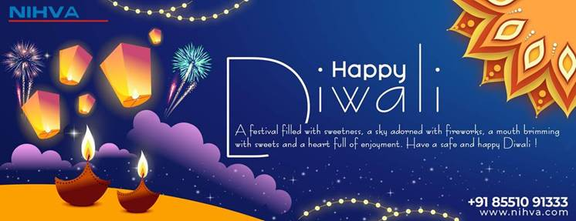

With best Regards,
Pratik Darekar
(Marketing)
9168940333
-------------------------------------------------
NIHVA Technologies Pvt. Ltd.
187, G-Block, Thermax chowk, MIDC
Chinchwad, Pune – 411019.
MOB: +91 9168940333
Email ID: marketing@nihva.com


